Town of Marshall

Fair Housing Complaint

Procedure
Any person or persons wishing to file a complaint of housing discrimination in the Town may do so by informing the Town or Sara Nichols at Land of Sky Regional Council of the facts and circumstance of the alleged discriminatory acts or practice.
Upon receiving a housing discrimination complaint, the Town shall acknowledge the complaint within 10 days in writing and inform the North Carolina Human Relations Commission about the complaint.
Sara Nichols, Regional Planner, Land of Sky Regional Council shall offer assistance to the commission through in the investigation and reconciliation of all housing discrimination complaints which are based on events occurring in the County.
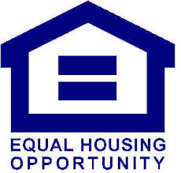
Where to Get Help and What to Do If You Are Discriminated Against
If you feel you have been discriminated against you can:
1. Contact Sara Nichols, Regional Planner at Land of Sky Regional Council, 339 New Leicester Hwy, Suite 140, Asheville, NC 28806. 828-251-6622. She will assist you with filing a complaint to the North Carolina Human Relations Commission.
2. Contact and/or file a complaint with the North Carolina Human Relations Commission, 1318 Mail Service Center, Raleigh, NC 27699-1318, or telephone the Commission at
919-733-7996.
3. Contact Pisgah Legal Services at 1-800-489-6144.
4. Contact the North Carolina Fair Housing Center at 919-667-0888.
5. Contact HUD – file complaint online. https://portal.hud.gov/FHEO903/Form903/Form903Start.action

